

**Rajshahi University of Engineering and Technology**

**Department of Electrical and Electronic Engineering**

**Course No. :** EEE 3200

**Course Name :** Electrical and Electronic Circuit Simulation Lab

**Experiment No. :** 08

**Experiment Name :** Introduction of Matplotlib Library in Python

|  |  |
| --- | --- |
| Submitted by,  **Shovon kumar Ray**  Roll :1910141  Section:c  Series:19 | Submitted to,    **Dr. Mohammod Abdul Motin**  Assistant Professor  Dept. of EEE  RUET |

Date of Experiment :December 4, 2023

Date of Submission : december11 , 2023

**Experiment No:** 08

**Experiment Name:** Introduction of Matplotlib Library in Python**.**

**Objectives:**

1-Gain a comprehensive understanding of the Matplotlib Library in Python.

2.Explore diverse problem-solving scenarios utilizing Matplotlib functions.

**Theory**: Matplotlib stands out as an exceptional visualization library for 2D plots of arrays in Python. Its robust capabilities stem from its compatibility with NumPy arrays and seamless integration with the broader SciPy stack. Originally introduced by John Hunter in 2002, Matplotlib has evolved into a powerful tool for data visualization on multiple platforms.Visualization, a pivotal aspect, facilitates a visual exploration of vast datasets through easily interpretable graphics. Matplotlib offers a rich array of plot types, including line plots, bar charts, scatter plots, histograms, and more, making it a versatile choice for various data representation needsLine plot: Line plots connect data points for continuous representation.

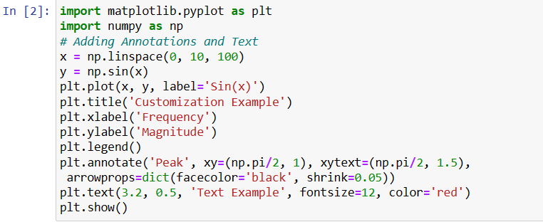

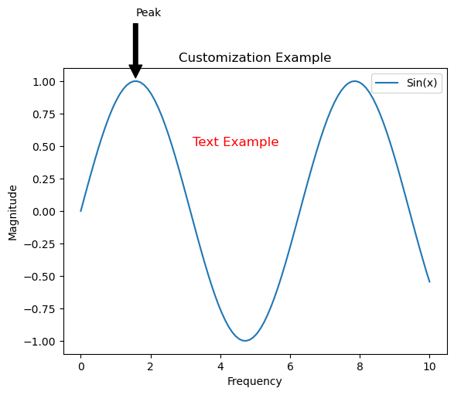

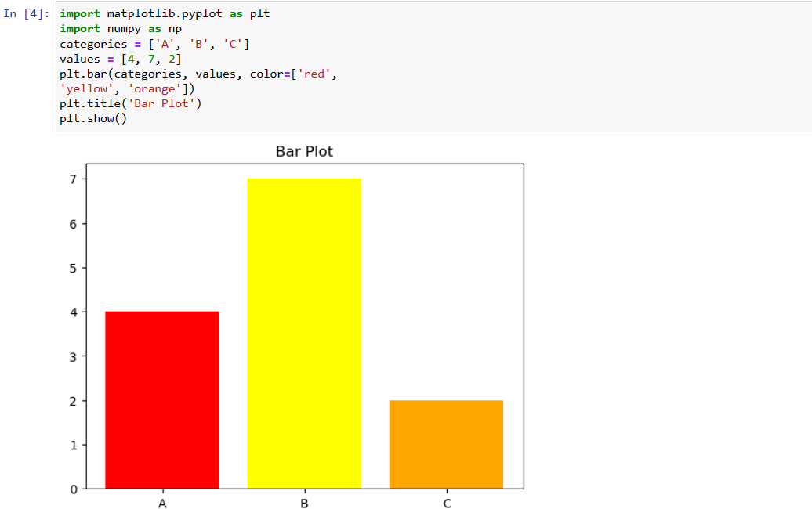

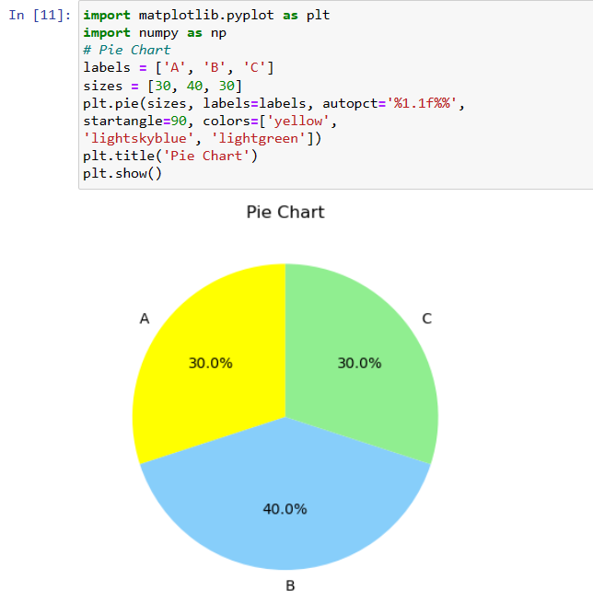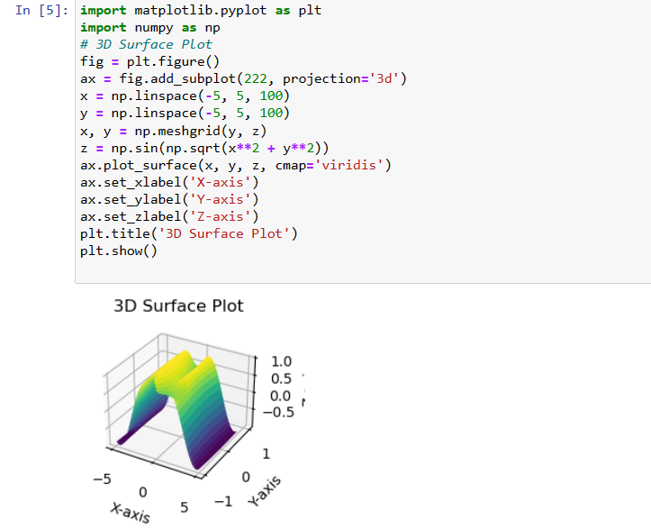

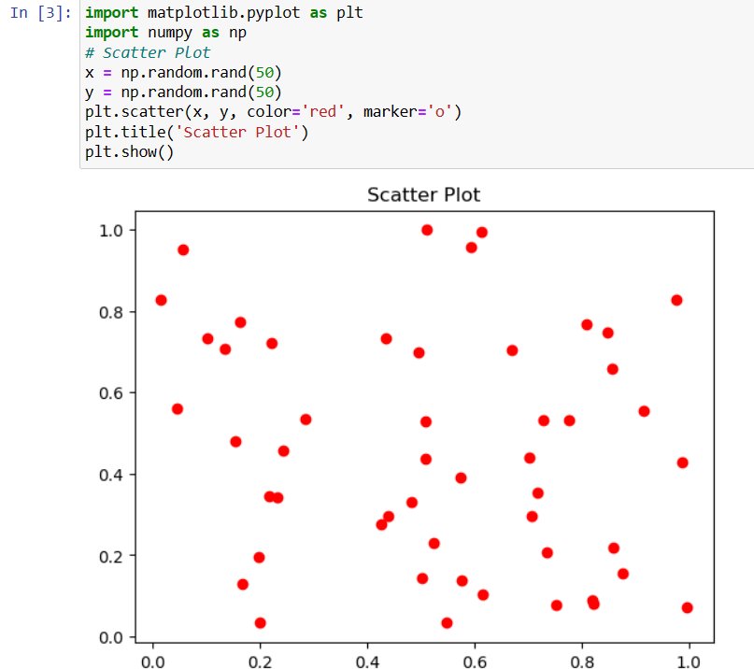

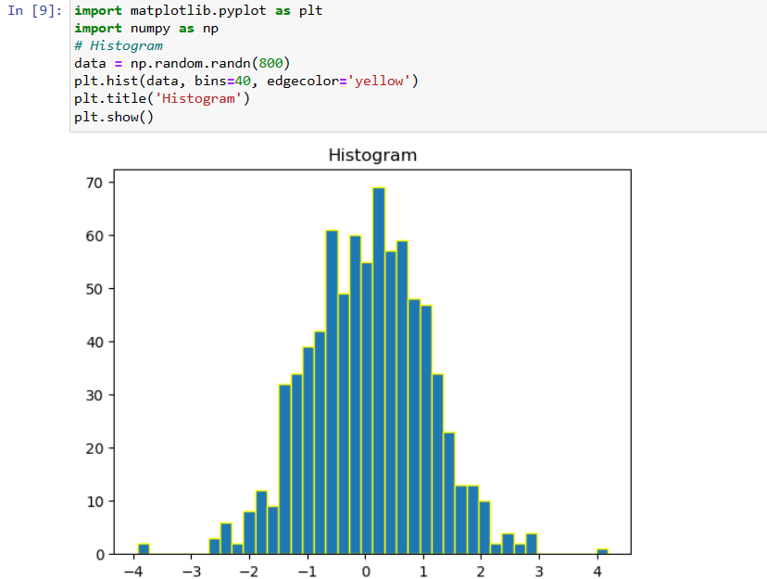

Matplotlib's ‘subplots()’ function is used to create a grid of subplots within a single figure, facilitating the simultaneous visualization of multiple plots. By specifying the number of rows and columns, this function returns an array of axes that can be customized independently.

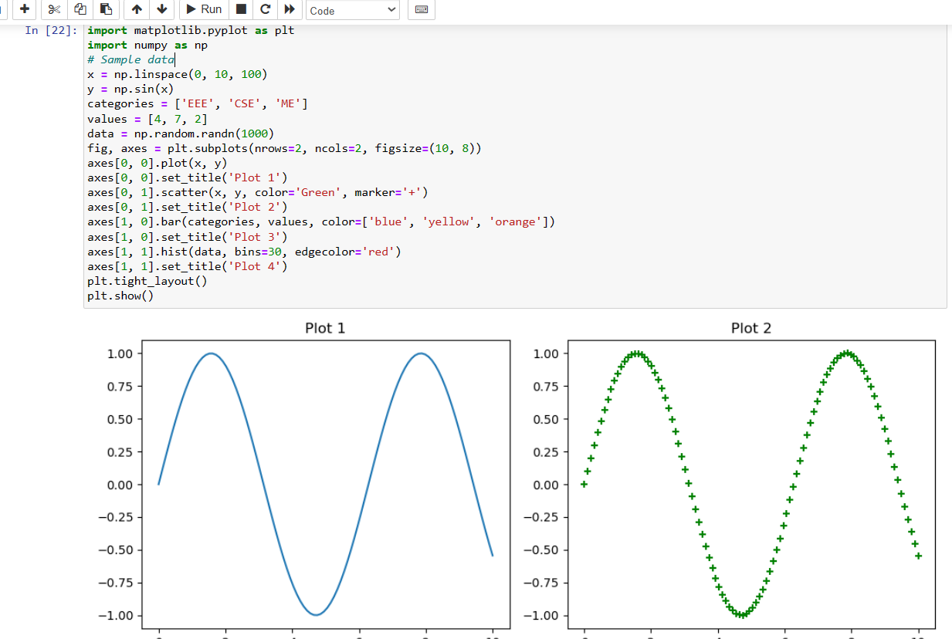

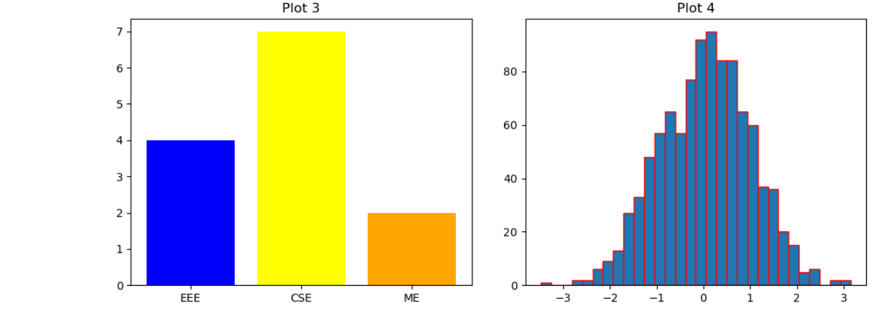

**Discussion and Conclusion;**In accords with experiment several library functions in pandas for data analysis was learned . Matplotlib, a distinguished data visualization library for Python, stands out for its intuitive design and remarkable versatility. Armed with a robust toolkit, it empowers users to effortlessly craft a diverse range of static, animated, and interactive plots. Matplotlib's allure lies in its user-friendly approach, making it accessible to both novices and seasoned users alike.In essence, Matplotlib not only simplifies the process of data visualization but also elevates it to an art form. The experiment introduced us to class object functions to perform different tasks involving these library functions. The tasks and objectives was obtianed in this experiment and various functions of matplotlib was carried out successfully.